**Name: Bhaskar Kewalramani**

**Tata Consulting Engineers**

**CASE STUDY**

**17.9.2024:**

**1. Choose the project from your comfortable programming language or pls refer the react project I have uploaded in the Micrsoft Teams.**

**2. Creating Commit Locally**

**3. Pushing the Code to the Owner's Remote Repository**

**4. Cloning the Project & Modifying the Code**

**5. Adding a Collaborator**

**6. Merging with Owner Branches**

**7. Fixing Merge Conflicts**

**8. Contributing to the Project to Improving the Code**

**9. Creating and Accepting Pull Request**

**10. Upload the document MS Teams wih your name and share your GitHub repo too.**

You need to create a word document where the commands and screenshots you can attach and at the end upload the document here or you can mail me at [pal.bhavna14@gmail.com](mailto:pal.bhavna14@gmail.com).

1. Choose the project repo – hello world
2. Clone in laptop

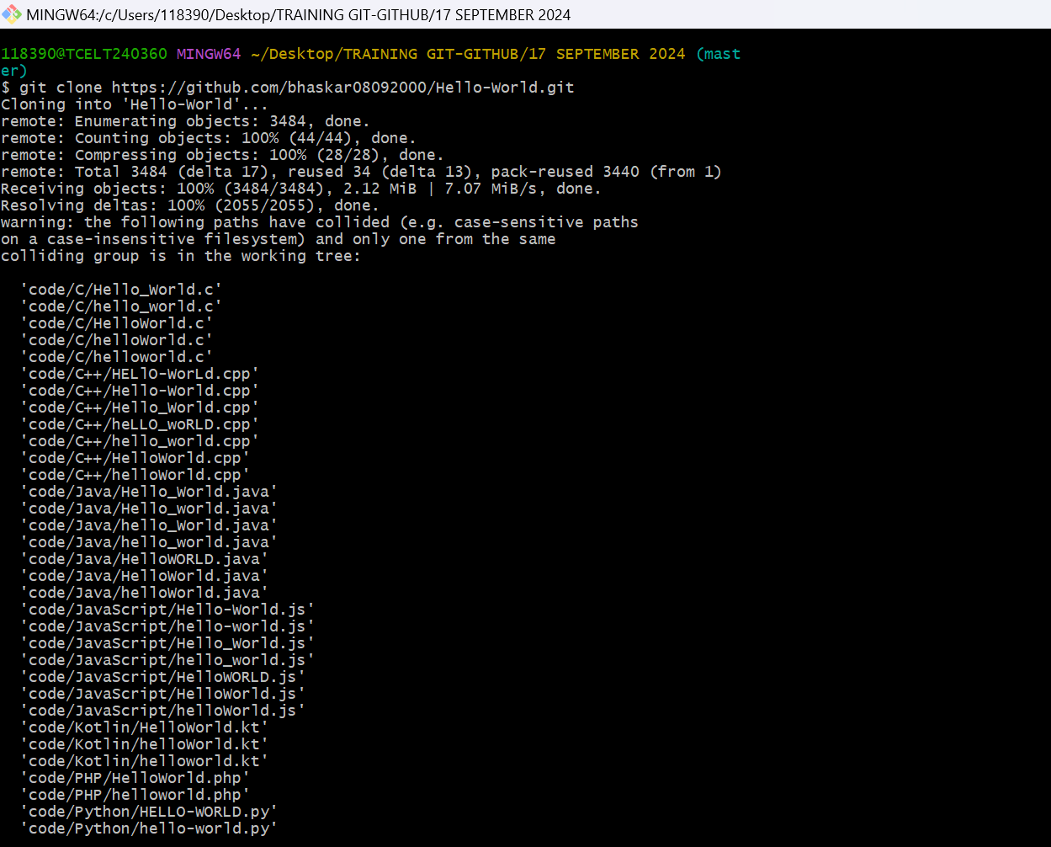

1. Change branch to new branch

1. After making changes , commit

-git add .

-git commit -m “changes made in crud project file.”

1. Push the project in original repo.
2. Now add a collaborator from github repository settings.
3. Resolve the merge conflicts
4. 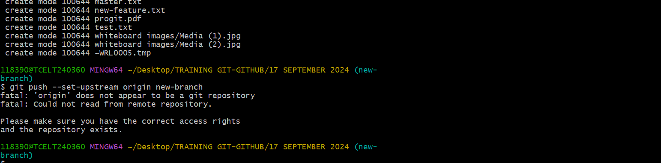
5. Finally upload the document.